Augusto De Muro, the unquestionable President of FIDE (1939-1946) /
Buenos Aires headquarters of the world entity from 1939 to 1946

By Sergio Ernesto Negri & Juan Sebastián Morgado

Chaired by Mr. Willy Iclicki, and with the assistance of members Mr. Casto Abundo, Mr. Andrzej Filipowicz and Mr. Berik Balgabaev, the FIDE Historical Committee invited numerous delegates and personalities to a ZOOM meeting on December 7, 2021, which was part of the Congress Virtual de FIDE 2021. More than 30 people participated, among them the Argentines Ing. Mario Petrucci, president of Argentine Chess Federation (FADA), and those who signed this note.

In this framework, the first item on the Agenda was analyzed, the proposal made by the FADA in order to recognize the decisions that were made in the FIDE Congress and Assembly in their meetings in Buenos Aires 1939, in the context of the Tournament of Nations and the Women's World Championship.

The Argentine position (Document I) was presented and was favorably received by the Chairman of the Committee. Members of the meeting requested access to the documentation mentioned in the exhibition, which it is shared now. Furthermore, a document is presented for the knowledge of those interested in the subject (Document II).

The next step will be the submission for consideration by the next FIDE Assembly, which is expected to take place in the course of 2022, the year in which the hundredth anniversary of the foundation of FADA will be celebrated.

1939’s Decisions

We trust that we are closer to the definitive recognition of two circumstances that were forgotten and denied: the appointment of the Argentine Mr. Augusto de Muro as President of FIDE and that of Buenos Aires as the headquarters of the entity, in both cases provisionally, which It happened in 1939 and was valid until the new Congress of the entity held in 1946. In 1939 three historical events took place in Buenos Aires: the Tournament of Nations, the Women's World Championship and the XVI FIDE Congress which, in the context of the declaration of World War II, made two crucial decisions that would be operational until next Congress:

1. Temporarily move its headquarters to Buenos Aires;
2. Appoint the Argentine Mr. Augusto De Muro –President of FADA– as President of FIDE, appointing Mr. Alexander Rueb as Honorary President;

The 4th session of the FIDE Congress was held on September 18, 1939. The aforementioned proposals were formulated by Dr. Luis Oscar Boettner, representative of Paraguay, doing so on behalf of his country and of Uruguay, Bolivia, Ecuador, Chile, Peru, Costa Rica and Guatemala. They were supported by the delegate of Denmark and had no votes against, registering four abstentions.

The Closing Assembly of the Tournament of Nations, which took place on Tuesday, September 19, 1939, starting at 11:30 am, chaired by the Uruguayan delegate and in the absence of Mr. Rueb, ratified the decisions of the Congress. In this framework, the appointment of Mr. De Muro as head of FIDE was formalized, with the unanimous support of the representatives of the following countries: Uruguay, Chile, Paraguay, Lithuania, Poland, Bolivia, Canada, France, Germany, Bohemia and Moravia, Hungary, Estonia, Peru, Brazil, Costa Rica, Cuba, Guatemala and Ecuador, plus the presence of Miss Mary Karff from the United States of America; and with the sole abstention of Argentina.

Mr. Rueb argued that these resolutions were resolved without being on the agenda. But the delegates considered, and this is evidenced in the history of the institution, that Congress is sovereign and could legally approve solutions to unforeseen problems: World War II had already been declared and, in these emergency conditions, Congress could and should take steps to safeguard FIDE's interests. (See addendum 2 Booklet of the XVI FIDE Congress edited by FADA in may, 1940)

Rueb, De Muro and Portela

Mr. Rueb never accepted the decision of Congress: he considered these decisions as a "coup d'état", but it could be better considered that it was actually the outgoing President who did not respect a decision made by the Assembly, the institution's highest and sovereign authority.

On the other hand, in Argentina, the correspondent of the newspaper La Nación and Argentine delegate to the FIDE Congress in 1928, Mr. Carlos Portela, had already expressed that Mr. Augusto De Muro was on his agenda and was recognized by him as the current President of FIDE in July of 1946. Let's see the full text of his article (in Spanish):

▓ Será reorganizada la entidad directora del ajedrez mundial. Caducas todas las autoridades de la FIDE, por imperio de su propio estatuto, y en la necesidad de retomar la dirección del ajedrez mundial unánimemente reclamada, el Dr. Rueb, activo expresidente por varios períodos, ha decidido convocar a las federaciones afiliadas tomando por base las que han ratificado su adhesión, y las adheridas hasta 1940. A tal efecto, y a invitación de la Federación Suiza, va a reunirse en Winterthur el XVII Congreso de la FIDE. Ya Don Augusto De Muro expresó en repetidas ocasiones su deseo que fuera precisamente Rueb, por su acción constante y sus prestigios, quien tomara tal iniciativa, reiterándolo con motivo de la vacancia del título mundial tras el fallecimiento de Alekhine. Como se recordará, el señor De Muro, a la sazón presidente de la FADA, fue elegido presidente de la FIDE por el Congreso celebrado en Buenos Aires, 1939, en ocasión del Torneo de las Naciones, cargo que decidió aceptar en atención a los acontecimientos que envolvieron al mundo, entendiendo que la sede de la FIDE no podía hallarse tan alejada de los centros ajedrecísticos más importantes del orbe.
La terminación de la guerra y la situación de las autoridades de la FIDE, cuyos mandatos han caducado, acentuaron la urgencia de resolver ese estado de cosas, entre las que tiene particular importancia el asunto del Campeonato del Mundo, que debe lógicamente ser dirigido y organizado por la FIDE, como lo ha sostenido reiteradamente La Nación. (See Addendum 3, Alekhine’s letters to FADA)

Summary of Portela’s article in La Nación:
- The governing body of world chess will be reorganized. All the authorities of FIDE have expired, and in the need to resume the direction, Mr. Rueb, has decided to accept the invitation of the Swiss Federation to host the XVII FIDE Congress in Winterthur,
- Already Mr. Augusto De Muro repeatedly expressed his wish that it was precisely Mr. Rueb, who would take such an initiative. As will be remembered, Mr. De Muro, then president of FADA, was elected president of FIDE by the Congress held in Buenos Aires, 1939, on the occasion of the Tournament of Nations, a position he decided to accept in response to the events that enveloped the world.

Documentary evidence

In addition, the current President of the FIDE History Committee, Mr. Willy Iclicki, found a document in the archives in which Mr. Rueb suspended the operation of FIDE from 1940, but without communicating it to the federations of the countries: that is why Mr. De Muro continued develoum1ping some activities in that condition, according to the mandate conferred in September 1939 in Buenos Aires. [See Addendum 1 FIDE documents and Grau’s text of may 18, 1940, in newspaper ¡Aquí Está!]

There is abundant documentation, disseminated in journalistic investigations, both in Argentina and abroad, including those carried out by Sergio Negri and Juan Morgado, which are available to the members of the FIDE History Committee and the international community in general, which was brought to the attention of Mr. Iclicki, whom we thank for his willingness to clarify what exactly happened at that time.
Today, a historical truth that was hidden for too long is closer to being recognized, especially that, with the elements provided and after consulting the FIDE archives, it is becoming clear that Rueb's position after the 1939 Buenos Aires Congress was not it was consistent, for what Mr. De Muro had validly assumed as the highest authority of the entity, in a fact that must be definitively consecrated. (See Addendum 5)

There is much evidence that Mr. De Muro was, after his legitimate appointment, recognized as President of FIDE by actors in the world chess community, important media and books by researchers from various countries:

a) Letter from the Designated Vice President of FIDE to Mr. De Muro from the American Mr. M. S. Kuhns dated September 26, 1939 (See Addendum 4)
b) Letters from world champion Mr. Alexander Alekhine to Mr. De Muro dated October 26 and 28, 1939, included in the FADA Bulletin
c) Numerous articles have been published in newspapers (La Nación, La Prensa, The Buenos Aires Herald), magazines (El Ajedrez Americano) and books (Pawns in a greater game, Justin Corfield; El impresionante Torneo de las Naciones 1939 (The impressive Tournament of Nations 1939), Juan Morgado; La generación pionera 1924-1939 (The generation pioneer 1924-1939), Sergio Negri and Enrique Arguiñariz; Remember 1939, José Copié; El Ajedrez en Perú (Chess in Peru), Felipe Pinzón Solís (member of the Peruvian national team in 1939)
d) Record that as President of FIDE, Mr. De Muro inaugurated the 1941 Mar del Plata Tournament (triumph of Mr. Gideon Ståhlberg, ahead of Mr. Miguel Najdorf and Mr. Erich Eliskases, in the presence of notorious chess players from all over the world)
e) Certified the 40 simultaneous blindfolded games that Mr. Miguel Najdorf played in Rosario, 1940, appointing Mr. Vicente Pomponio as referee, a session that represented at that time a world record that was not later recognized
f) Various interviews in the media, for example the one he did on Radio Rivadavia in December 1945
g) Mr. De Muro attended the inauguration of the II Tournament in Memory of Roberto Grau (FIDE founder chess player who had died the previous year) at the Círculo de Ajedrez de Buenos Aires (an important local chess-club) in 1945

Conclusions on the effective assumption of the presidency by Mr. De Muro

It could be concluded saying that, by decision of the FIDE Congress of 1939, endorsed by the Assembly:
1. Mr. De Muro was appointed Provisional President of FIDE, a position that corresponded temporarily between September 1939 and 1946, the date of the following Congress
2. The city of Buenos Aires was provisionally designated the headquarters of FIDE for the same period

To date, both episodes have been the subject of what we call "historical surgery" which, in homage to the truth, must be reviewed and reversed, acknowledging facts that had real entity and legal value, in a decision adopted in the extremely difficult emergency conditions in that the world was experiencing in 1939 when, at the same time as the Tournament of Nations and the Women's World Championship, the Second World War began in Europe.

The next FIDE Congress was held seven years later, between July 25 and 27, 1946 in Winterthur (Switzerland), where only 9 delegates attended, in the absence of all the Latin American delegations. There Mr. Rueb was once again appointed President of FIDE without referring to the corresponding transfer of command —from Mr. De Muro to Mr. Rueb— and resuming the mandate as indicated by the well-known historical line of time, assuming the presidential period 1924-1946 without interruptions, which clearly it does not adjust to what really happened and ignoring the decisions adopted by the previous Congress of the entity held in Buenos Aires 1939.

Let us remember that Mr. Erwin Voellmy stated that: "during the war period, no European Federation made contributions to the entity, with the exception of Denmark, so FIDE had practically ceased to exist". Also, who was a Swiss delegate in several Congresses, pointed out that FIDE did not hold congresses from 1940 to 1945. In this European perspective, which does not seem to consider what was done in the American continent by the President of the legal FIDE, Mr. Augusto de Muro, the supposed mandate that Mr. Rueb would have had should cease immediately from that year of 1940.

In this line of analysis the historian Mr. Edward Winter coined the term "interregnum" to refer to FIDE's actions during the armed conflict, denoting its inaction, but that is worth, we insist, only from a perspective focused on a Europe that was the central stage of the world conflict, but not considering what was done in America since the representation of the world entity as decided in 1939.

Therefore, it is fitting that Mr. Augusto De Muro be included as President of FIDE for the period 1939/1946. Before and after, in the gallery of former Presidents of the entity, Mr. Alexander Rueb must appear. In this way, a historical fact will be recognized that we have called, alluding to the Argentine, "the unqustionable President of FIDE”

FIDE America and FADA's centenary

The current FADA Board of Directors led by Mr. Mario Petrucci, after 82 years rescues from oblivion the decisions made by the FIDE Congress of 1939, vindicating the chess of the country and the continent and the historical truth.

We are on the eve, so we hope, that the world entity finally recognizes historical events that occurred in a corner of the south back in 1939. At that time, Argentina, and several countries of the American continent, were a place of contention and the possibility of rebuild their lives for so many European chess players who were unable to return to their homes. At that time, Buenos Aires offered to be the provisional host of a world entity that could run the risk of losing its headquarters. At that time the Argentine Mr. Augusto De Muro was able to take over from Mr. Alexander Rueb, faced with the uncertainty of what was to come.

Faced with the healthy decision of FADA and FIDE-AMÉRICA (which formally adhered to the Argentine proposal) to promote the recognition of these facts and open the stage for FIDE to end up recognizing an undoubted historical truth that was kept hidden for too long, we end up just expressing: Congratulations! Once again we are being faithful to the motto of our world entity: Gens una sumus!

DOCUMENT I: POSITION PRESENTED BY NEGRI & MORGADO, ON REPRESENTATION OF ARGENTINA, BEFORE THE FIDE HISTORY COMMITTEE ON DECEMBER 7, 2021

“THE MISSING PRESIDENT” (MR. AUGUSTO DE MURO) AND BUENOS AIRES PROVISIONAL HEADQUARTERS OF FIDE (FROM 1939 TO 1946)

In 1939, three historical events took place in Buenos Aires: the Tournament of Nations, the women's world championship and the XVI FIDE Congress which, in the context of the declaration of World War II, made two decisions:
1. Provisionally move its headquarters to Buenos Aires
2. Appoint the Argentine Mr. Augusto De Muro as President of the organization (appointing Mr. Alexander Rueb as Honorary President)
These decisions were to operate until the next FIDE Congress.
The 1939 FIDE Congress was issued in its fourth session on September 18, 1939.
The aforementioned proposals were formulated by Dr. Luis Oscar Boettner, representative of Paraguay, doing so on behalf of the Federation of his country and of Uruguay, Bolivia, Ecuador, Chile, Peru, Costa Rica and Guatemala. It was endorsed by the delegate of Denmark. And it did not deserve any rejection.
The Closing Assembly of the Tournament of Nations, which took place on Tuesday, September 19, 1939 starting at 11:30 am, presided over by the delegate of Uruguay, and with the absence of Mr. Rueb, ratified the decisions of the Congress.
De Muro's appointment was then formalized with the unanimous support of Uruguay, Chile, Paraguay, Lithuania, Poland, Bolivia, Canada, France, Germany, Bohemia and Moravia, Hungary, Estonia, Peru, Brazil, Costa Rica, Cuba, Guatemala and Ecuador, plus the presence of Miss Mary Karff from the USA; and with the sole abstention of Argentina.
Some final considerations:
It was stated that the issue was resolved without it being on the agenda. But Congress is sovereign so it could legally introduce unforeseen issues. In addition, the Second World War was supervening at the time of its convocation (it was declared on September 1st. 1939 while the Buenos Aires tournaments were being played). Under these conditions, the Congress could and should take measures to safeguard the interests of the FIDE.
Mr. Rueb never accepted the congressional decision. He considered it a "coup d'état" when what could well be considered is that the outgoing President did not respect a decision taken by the sovereign authority of the institution.
There is journalistic documentation and research, both in Argentina and abroad, including those made by Negri and Morgado that are available to the members of the FIDE History Committee and the international community in general, which were brought to Mr. Willy Iclicki, to whom we thank very much for his attention and good disposition, which are explicit about what happened on that occasion.
Mr. Iclicki thoroughly consulted the FIDE archive and we understand that he came to the conclusion that Mr. Rueb's position on this point was not consistent and that Mr. De Muro had indeed validly assumed the FIDE presidency.
There are documents that prove that Mr. De Muro was recognized as FIDE President, including the letter from designated FIDE Vice President Mr. M. S. Kuhns dated September 26, 1939, and letters from world champion Alexander Alekhine to Mr. De Muro dated October 26 and 28, 1939.
In practice, however, his role was limited to the South American sphere. There are numerous journalistic articles in newspapers (La Nación, La Prensa, Buenos Aires Herald), magazines (El Ajedrez Americano) and books (Pawns in a greater game, Corfield; El impresionante Torneo de las Naciones 1939, Morgado; La generación pionera 1924- 1939, Negri and Arguiñariz; Remember 1939, Copié; El Ajedrez en Perú, Felipe Pinzón Solís, member of the Peruvian team in 1939). (See Addendum 6)
Detail of this action:
a) De Muro inaugurated the Mar del Plata 1941 Tournament in his capacity as President of FIDE and FADA
b) He endorsed as FIDE President the 40 blind simultaneous that Miguel Najdorf played in Rosario, Argentine
c) Acting as president of FIDE, he was reported on Radio Rivadavia in December 1945
d) He attended the inauguration of the II Tournament in Memory of Roberto Grau in El Círculo in 1945
In conclusion, it could be said that, by decision of the 1939 FIDE Congress (endorsed by the Assembly):
1. De Muro was designated Provisional President of FIDE, a position that corresponded to him temporarily between September 1939 and 1946 (date of the next Congress of the entity)
2. The city of Buenos Aires was provisionally designated in the same period as the headquarters of FIDE
Both episodes have been object, to date, of a "historical surgery" that, in homage to the truth, must be reviewed, recognizing facts that were real and the product of decisions taken in legal form.
At the FIDE Congress held between July 25 and 27, 1946 in Winterthur, Switzerland without the presence of the Argentine delegation, or any other Latin American, Mr. Rueb was again appointed President of the Federation, resuming the mandate as is marked by the known historical line of facts.
We are very grateful to Mr. Petrucci, the first President of FADA to rescue the issue from oblivion, promoting the respective historical vindication; to FIDE-AMÉRICA, for having endorsed the initiative, and to the FIDE authorities for having opened the respective institutional investigation which, we trust, will lead to full future recognition of these episodes that occurred within the framework of the Good Nations Tournament of Buenos Aires, in 1939.

Sources (in English):

The day FIDE temporarily moved to Buenos Aires and Mr. Augusto De Muro was elected its President: Closer to the recognition by the world entity of a historical truth, by Negri & Morgado, at https://wordpress.com/post/ajedrezlatitudsur.wordpress.com/10525

The day FIDE temporarily moved to Buenos Aires and Mr. Augusto De Muro was elected its President, by Negr & Morgado, at https://wordpress.com/post/ajedrezlatitudsur.wordpress.com/11462
Sources (in Spanish):

El día en que la FIDE se muda provisoriamente a Buenos Aires, por Negri y Morgado, en https://ajedrezlatitudsur.wordpress.com/2021/04/09/el-dia-en-que-la-fide-se-muda-provisoriamente-a-buenos-aires/ y https://es.chessbase.com/post/el-dia-en-que-la-FIDE-se-muda-previsoriamente-a-buenos-aires-articulo-por-sergio-negri-y-juan-morgado.

El día en que la FIDE se muda provisoriamente a Buenos Aires, addenda (postdata), por Negri y Morgado, en https://ajedrezlatitudsur.wordpress.com/2021/04/23/el-dia/ y https://es.chessbase.com/post/postdata-articulo-el-dia-que-lafide-se-muda-provisoriamente-a-buenos-aires.

Addendum 1
Pages 13, 14 and 15 of the minutes of the FIDE Archive written by Mr. Rueb where he reports on the proposal "of the 8" and the reasons why he rejects it. (Document presented by Mr. Willy Iclicki). Article by Grau, may 18th, 1940 in ¡Aquí Está!

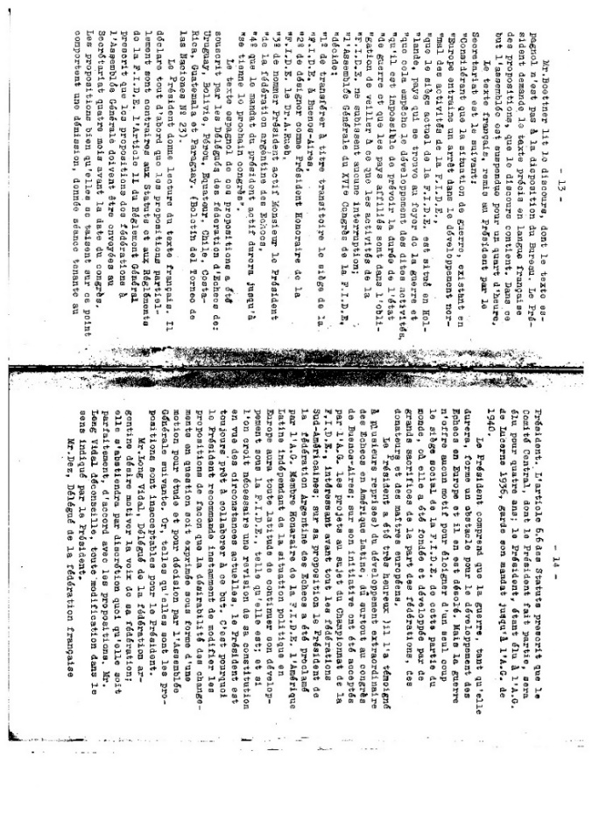
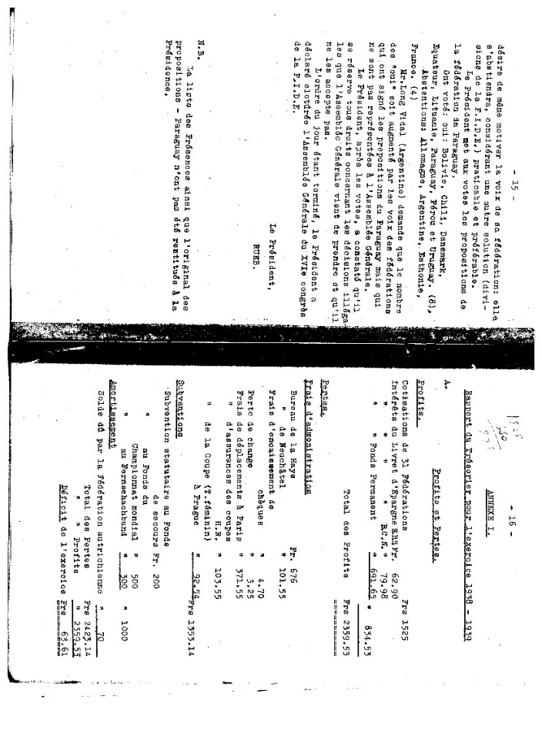
Durísimo ataque de Grau a Rueb

El doctor Rueb pretende crear un cisma en el ajedrez mundial: no se resigna a que sea Buenos Aires la sede del ajedrez mundial. Por unanimidad de votos, y premiando el esfuerzo más extraordinario de la historia del ajedrez, Buenos Aires fue elegida como nueva sede de la FIDE y el señor Augusto De Muro su presidente. Pero apenas regresó a Europa, el doctor Rueb negó legalidad a la resolución de marras, y pese a todas las federaciones del mundo, proclamóse único y verdadero presidente. Al iniciarse la disputa del Torneo de las Naciones, el doctor Rueb dirigió la palabra a los aficionados argentinos, única tarea que se ha reservado cada dos años, cuando hace turismo en compañía de su esposa. El hombre suele identificarse con sus esfuerzos. Cobra cariño a sus actividades, y si es director deportivo, a menudo se olvida de que ejerce un mandato y que sólo es representante de la voluntad de quienes lo designaron. Esto ha sucedido hasta la saciedad, y ésta es la causa por la cual notables directores de federaciones y de clubs, que en la primera hora fueron elementos indispensables para el triunfo, fracasan lamentablemente más tarde, y deben ser desalojados violentamente de los puestos que consideran como un bien propio. La FIDE fue durante muchos años ejemplo cabal de esto. Elegido presidente de la misma en el Congreso de París de 1925, el doctor Rueb, con el voto de todos los que tuvimos la fortuna de fundar la FIDE, fue el representante de Holanda un eficaz continuador de la obra iniciada. Se convirtió en el nervio de la misma, y su tino fue aplaudido en más de una oportunidad. Pero fue perdiendo poco a poco la visión de los problemas fundamentales. Dirigía la administración de la FIDE desde su hogar y nunca hubo un orden en la misma, ni un archivo que guardara la verdadera historia de la FIDE.
La FIDE eran él mismo y su memoria, y los problemas fundamentales del ajedrez mundial, entre ellos el campeonato, nunca fueron tratados con la energía y la autoridad necesarias. El doctor Rueb no podía hacer esto por dos cosas. Primero, por su falta de relación con la mayoría de los maestros. Después, por su vinculación con el doctor Euwe, que fue siempre en realidad el defensor de sus actitudes. Euwe es el Papa negro de la FIDE. Fue eficaz mientras figuró entre los aspirantes al título; resultó peligroso cuando se sumó a la lista de los interesados en su disputa. Los Congresos de la FIDE se realizaron siempre durante la disputa de los Torneos de las Naciones, pero el orden del día para los mismos, así como la designación de autoridades, se efectuaban en pequeñas reuniones que realizaban en alguna ciudad europea los miembros del comité ejecutivo y algunos delegados que recibían poderes para actuar en los mismos.
De esta forma se escamoteaba a los grandes congresos la posibilidad de remover la mesa directiva, y de encarar asuntos de real importancia, como juzgar actitudes y eficiencias. El doctor Rueb se convirtió, poco a poco, en el dictador de la FIDE, y en un viajero que todos los años se hacía pagar los gastos de su esposa para actuar en los congresos, que debían tratar tontas órdenes del día e inaugurar solemnemente los grandes torneos por equipos, única actividad eficaz de la FIDE: era necesario terminar con un estado de cosas tan anormal. Rueb había convertido a la presidencia de la FIDE en un bien propio, en los debates hacía respetar la orden del día cuando le convenía, e incorporaba asuntos cuando éstos eran propiciados por él o por la Federación Suiza, que lo seguía fielmente. De hecho, el tesorero de la FIDE a perpetuidad, el señor Nicolet, era uno de sus miembros. Así lo entendieron en Buenos Aires los delegados, que, extrañados ante la forma de conducir los debates, la ausencia de un programa y la carencia de datos concretos sobre la administración de la FIDE, agregados al problema del momento planteado por la guerra, –que habría de agravar esta inercia– resolvieron designar sede provisoria de la FIDE a Buenos Aires, por su gran alejamiento del conflicto; y al presidente de la FADA, don Augusto De Muro, presidente de la FIDE, premiando así su esfuerzo más extraordinario que registra la historia del ajedrez mundial en todo su desarrollo. La resolución se adoptó por absoluta unanimidad de votos. Hubo alguna abstención, que en la reunión final de la clausura del congreso, desapareció, pues el acta fue firmada por todos los delegados.
Quiere decir que había un acuerdo perfecto y que era evidente el deseo de separar al doctor Rueb del puesto que él conservaba por haber siempre escamoteado la consideración de sus actos, y haber resuelto que las reelecciones no se efectuaran en los grandes congresos a que dan lugar los Torneos de las Naciones. Pero el doctor Rueb no se resignó, y una vez en Europa, se dedicó a escribir cartas negando la legalidad de la resolución de Buenos Aires, y proclamándose único y verdadero presidente de la FIDE, mal que le pese a todas las federaciones del mundo. Es una postura pueril y un tanto ridícula, pero que podría dañar al ajedrez del mundo, ya que no faltarían algunas federaciones que prefirieran alejarse hasta tanto el conflicto se resuelva. Pero la guerra ha evitado esto, y hasta el momento sólo dos federaciones del mundo, la de Costa Rica y la de Suiza, parecen apoyar al doctor Rueb en su actitud. La primera, sin duda, por estar mal informada del problema, y la segunda, porque el señor Nicolet se niega a entregar los pesos que se encuentran en su poder y el cargo que el presidente derrocado le asignó, también a perpetuidad. Es un asunto desdichado, que puede llevar a conmover las bases de la FIDE, por la dificultad que existe en aclararlo y por la gran confusión de la situación mundial. Y que por primera vez ve la luz pública ante la campaña un tanto turbia del bueno del doctor Rueb, autopresidente de la FIDE, que no se resigna a la realidad. [Roberto Grau, ¡Aquí Está!, 18 de mayo de 1940]

Summary of Grau’s article

Dr. Rueb intends to create a schism in world chess: he is not resigned to Buenos Aires being the seat of world chess. By unanimous vote, and rewarding the most extraordinary effort in the history of chess, Buenos Aires was chosen as the new headquarters of FIDE and Mr. Augusto De Muro its president. But as soon as he returned to Europe, Dr. Rueb denied legality to the aforementioned resolution, and despite all the federations in the world, he proclaimed himself the only true president. (…)
The FIDE Congresses were always held during the Nations Tournament dispute, but the agenda for them, as well as the designation of authorities, were carried out in small meetings held in some European city by the members of the executive committee, and some delegates who received powers to act in them.
In this way, the possibility of removing the board of directors, and of dealing with matters of real importance, such as judging attitudes and efficiencies, was hidden from the great congresses. Dr. Rueb became, little by little, the dictator of FIDE (…): it was necessary to put an end to such an abnormal state of affairs. (…)
This is how the delegates understood it in Buenos Aires, who, surprised at the way the debates were conducted, the absence of a program and the lack of concrete data on the administration of FIDE, added to the problem of the moment posed by the war, –which would have to aggravate this inertia– they decided to designate FIDE's temporary headquarters in Buenos Aires, due to its great distance from the conflict; and the president of FADA, Mr. Augusto De Muro, president of FIDE, thus rewarding his most extraordinary effort that records the history of world chess in all its development. The resolution was adopted by absolute unanimous vote. There was some abstention, which disappeared at the final closing meeting of the congress, since the minutes were signed by all the delegates.
It means that there was a perfect agreement and that it was evident the desire to remove Dr. Rueb from the position that he held for having always hidden the consideration of his actions, and having resolved that re-elections should not be held in the great congresses to which they give rise. the Tournaments of Nations. But Dr. Rueb did not give up, and once in Europe, he dedicated himself to writing letters denying the legality of the Buenos Aires resolution, and proclaiming himself the only true president of FIDE, despite all the federations in the world. It is a puerile and somewhat ridiculous position, but one that could harm world chess, since there would be some federations that would prefer to stay away until the conflict is resolved. [Roberto Grau, ¡Aquí Está!, May 18, 1940]

Addendum 2 (English, French)
Summaries Argentine version of the events developed in the three sessions of the XVI Congress of FIDE 1939. The differences between Mr. Rueb's version and this one can be appreciated. Mr. Rueb does not recognize the closing version where the federations unanimously vote on the resolutions.
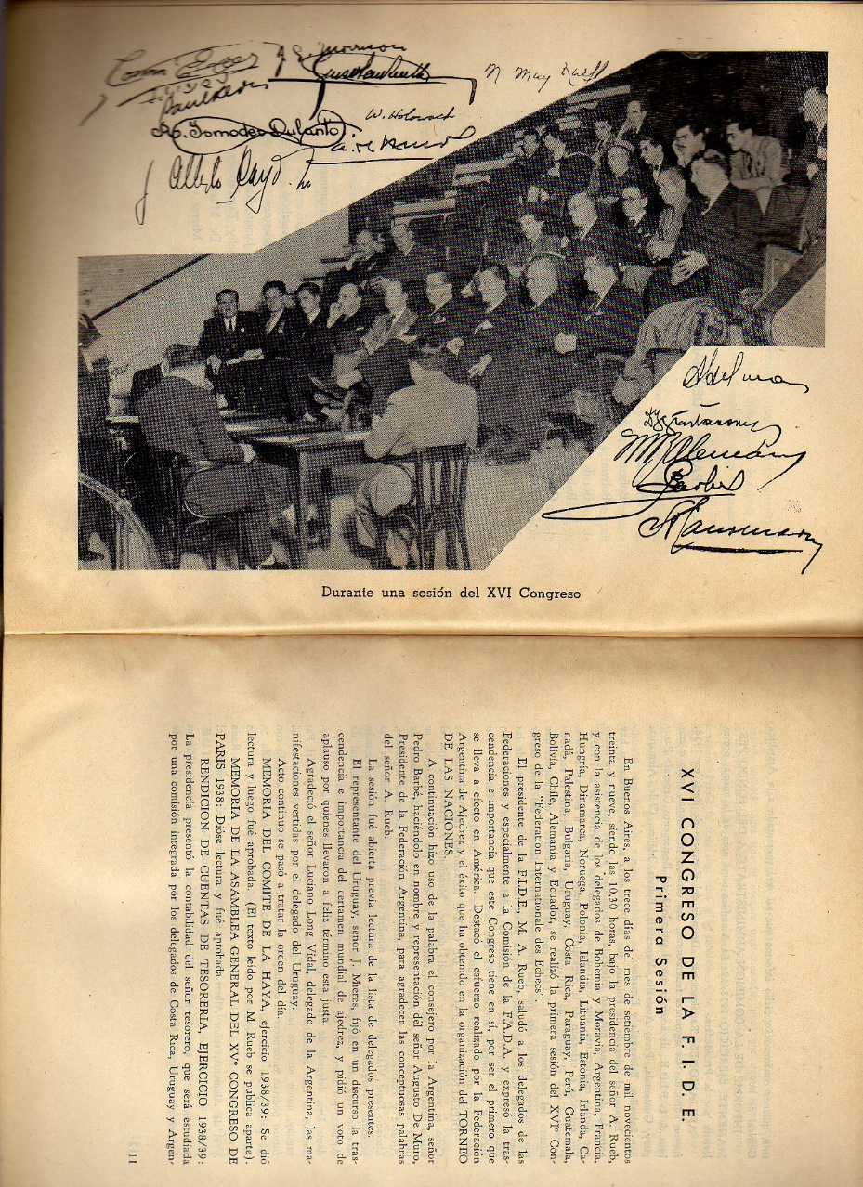
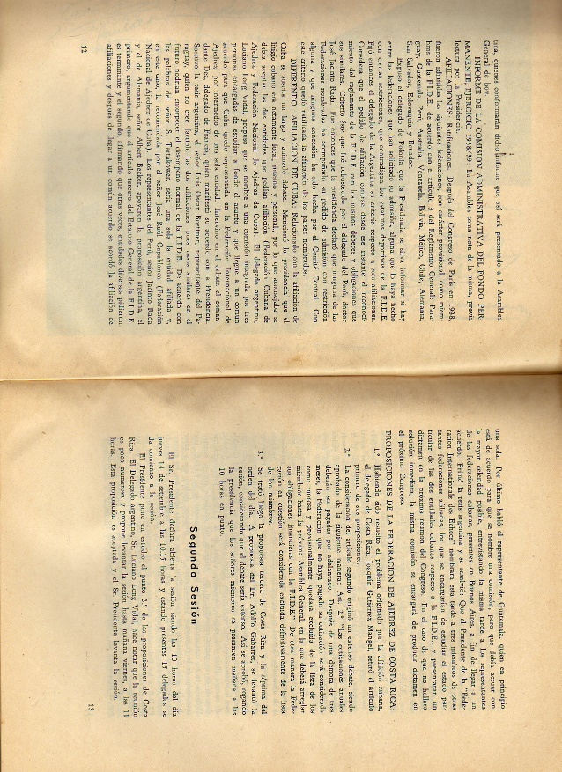

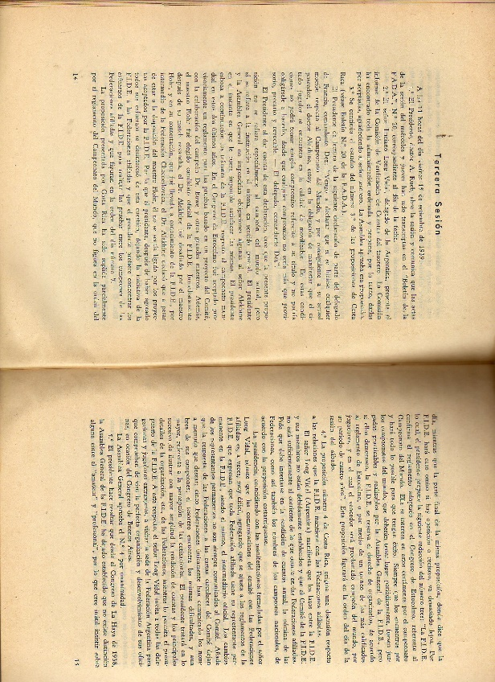

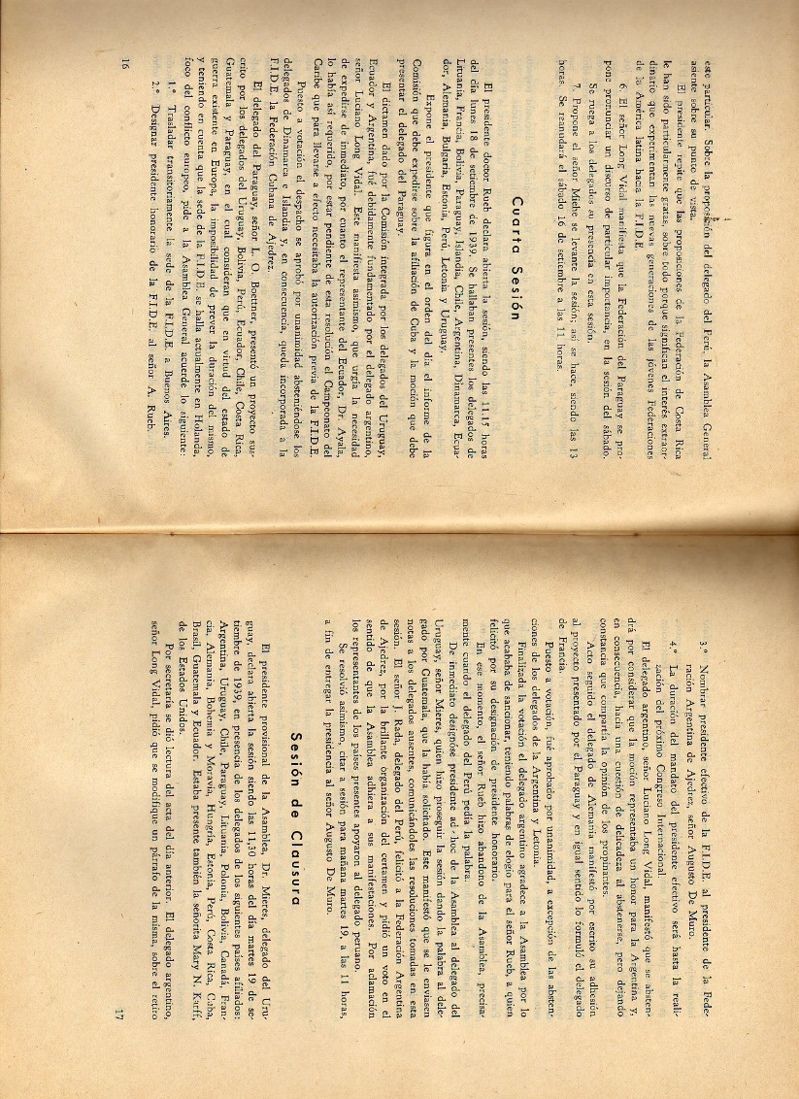
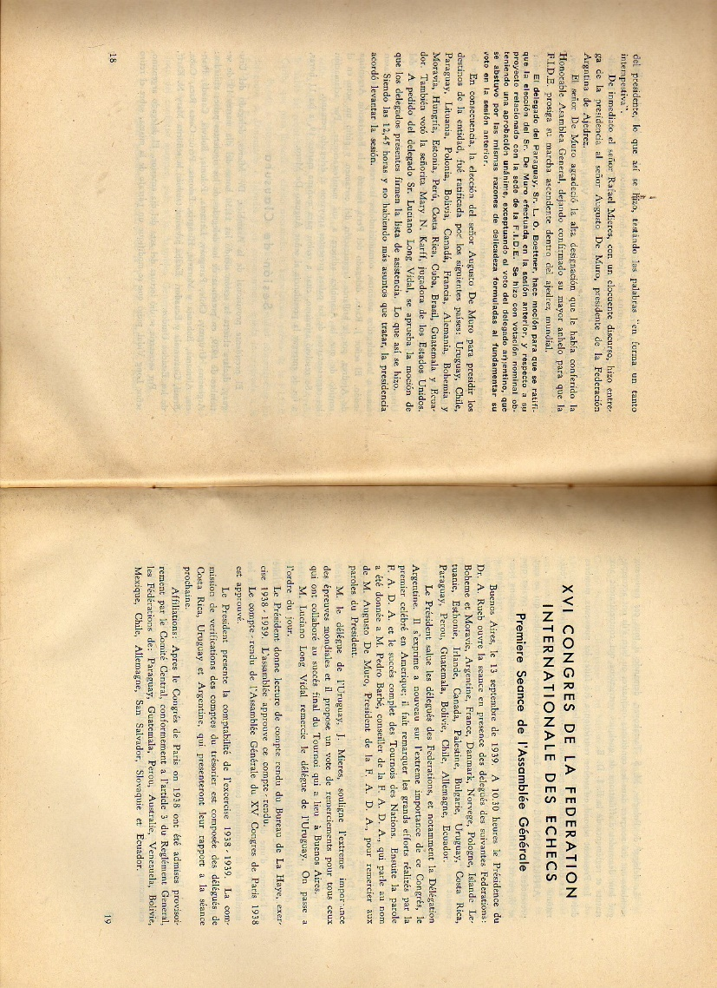

Addendum 3
Alekhine's letters of October 25 and 28
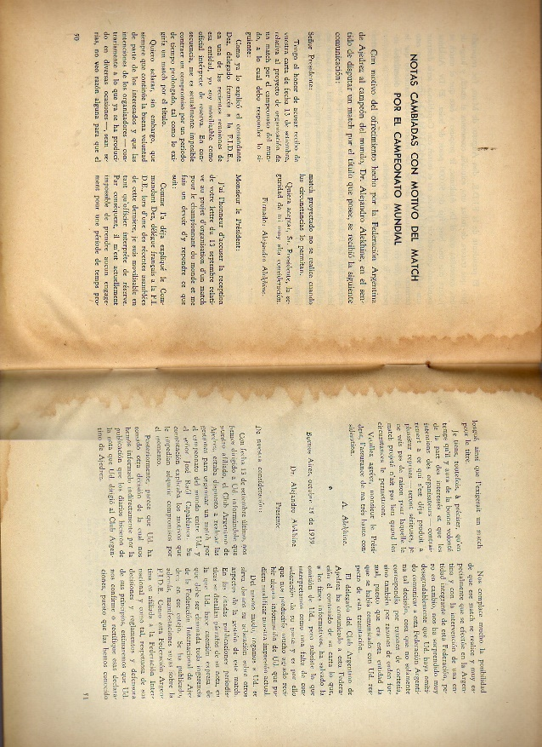

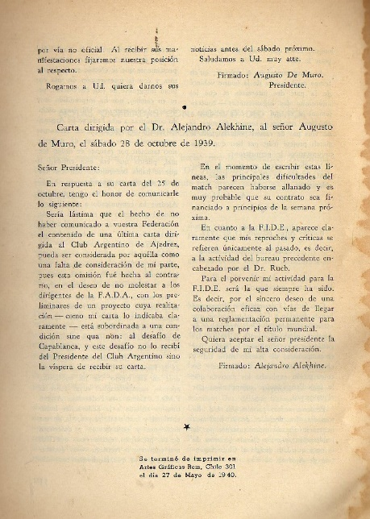

Addendum 4
Letter from Mr. M. S. Kuhns, September 26, 1939
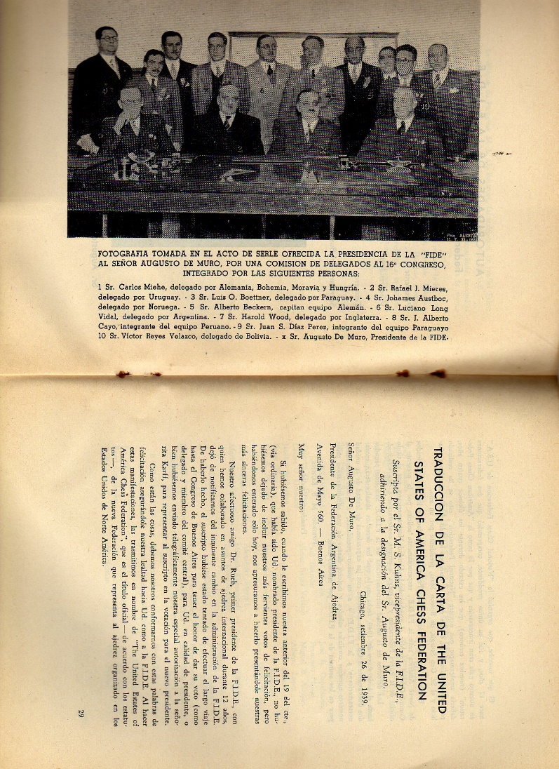
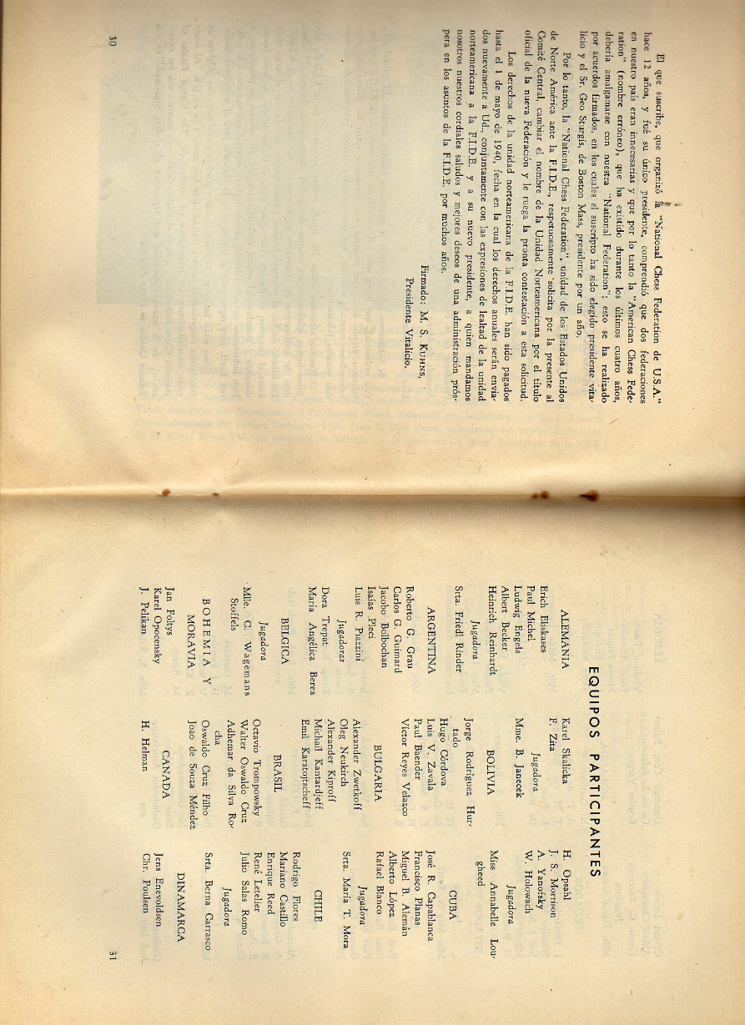

Addendum 5
FIDE Board of Directors post XVI Congress, with Mr. De Muro as President.
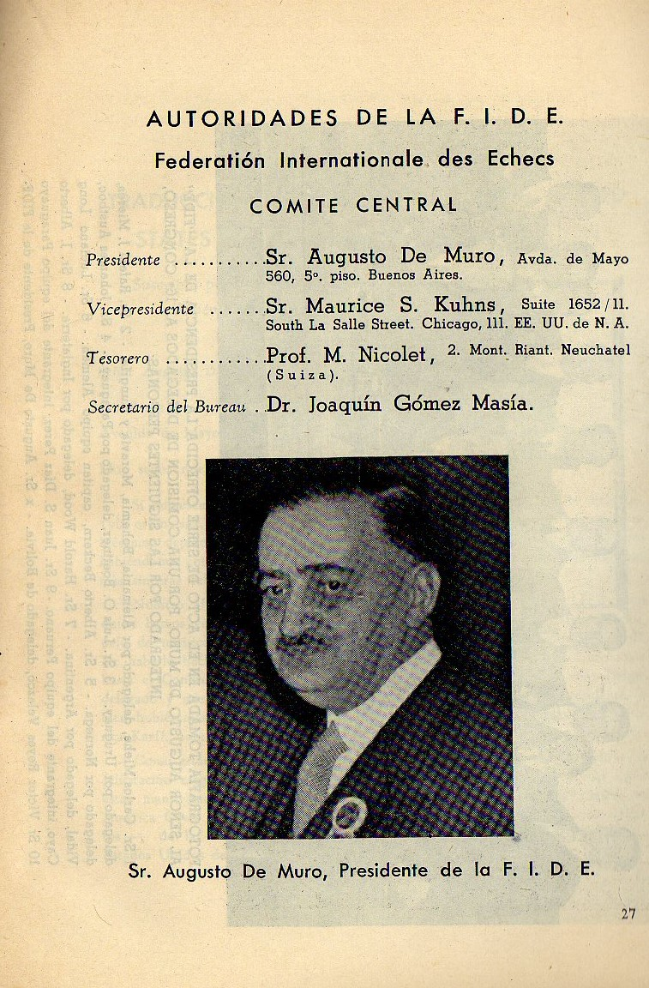

Addendum 6
Recognition of Mr. Augusto De Muro as President of FIDE in newspapers / FIDE temporarily moves to Buenos Aires.

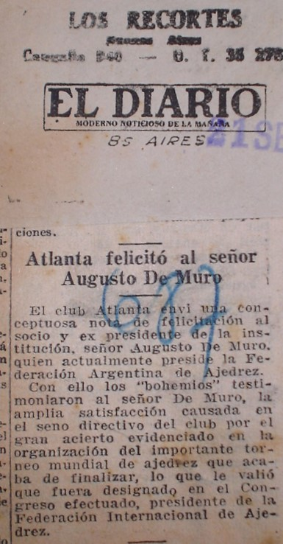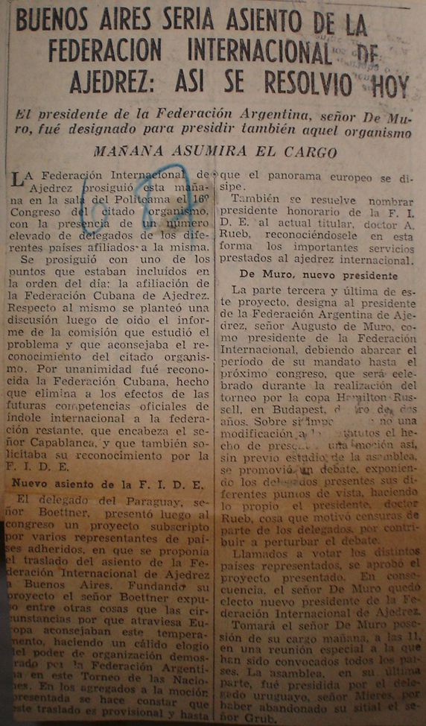
El Diario, September 21, 1939; La Razón, September 16, 1939

Last session of the FIDE Congress
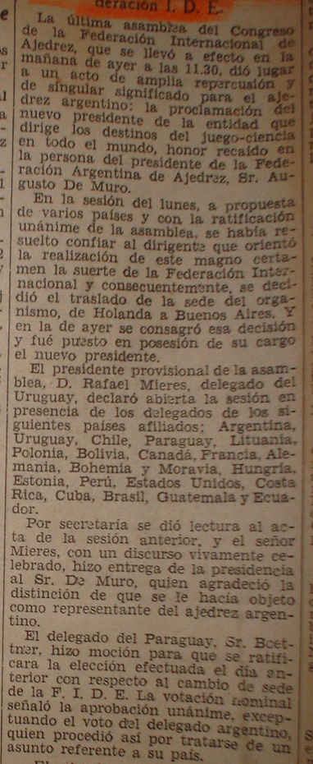
La Nación, September 30, 1939

Mr. Alexander Rueb was present at the closing ceremony and participated in the award ceremony.

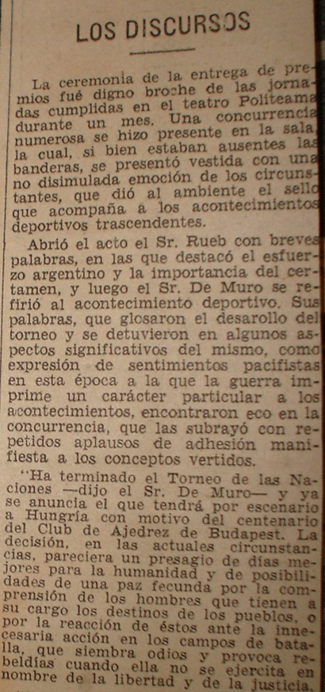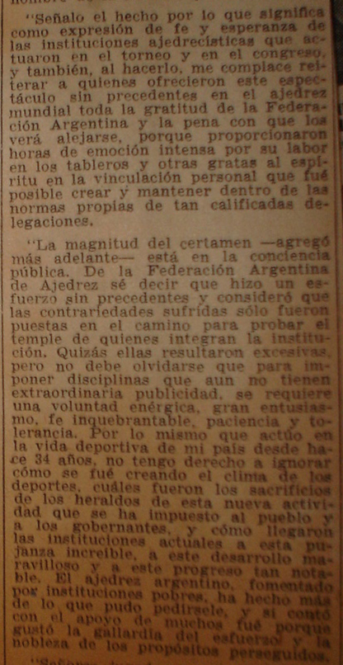
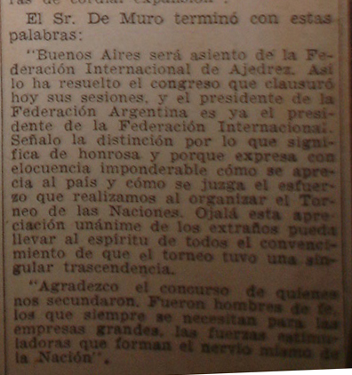
La Nación, September 20, 1939 (3 press clippings)

Mr. De Muro to the presidency
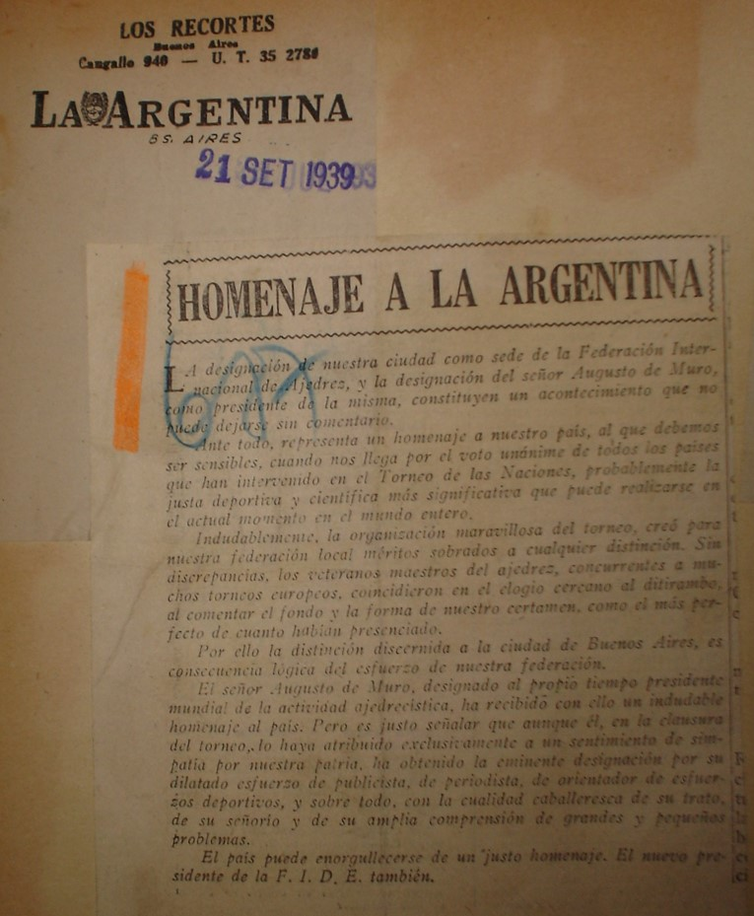
La Argentina, September 21, 1939

Repercussions in Montevideo, Uruguay.
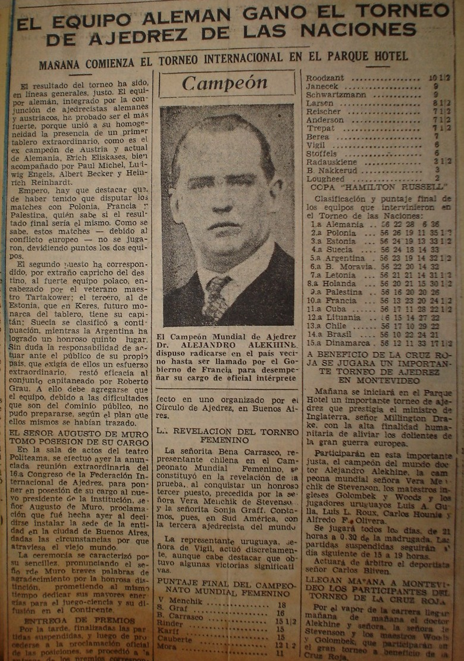
El Diario (Montevideo), September 30, 1939

FIDE to Buenos Aires.
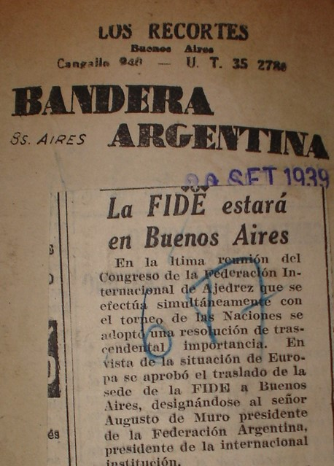
La Bandera, September 20, 1939

Grau on the transfer of the headquarters.
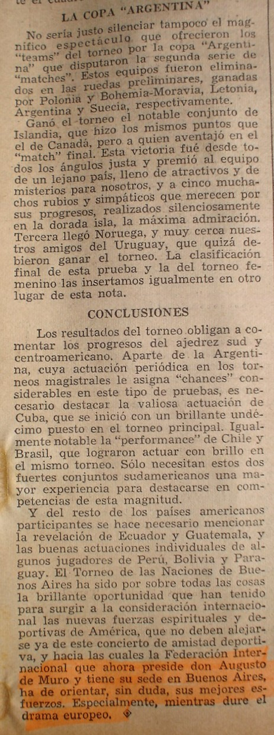
Leoplán, October 11, 1939

Carlos Portela, La Nación, July 12, 1946. Mr. Portela was one of the promoters of the elimination of the distinction between amateurs and professionals. Report presented by Grau: The 1928 FIDE Congress was closed, and the Argentine delegate Mr. Carlos Portela once again stood out when dealing with the matter of professionalism, managing to make the German and British theses triumph that maintains that it is impossible to make an exact classification between amateurs and professionals. Consequently, FIDE will not consider in the future distinctions between the two, and differences will only be established in terms of capacity, the only ones possible to identify. Most of the players have left for Germany in order to attend the big tournament that will take place with the participation of Capablanca in Bad Kissingen. [Special, Roberto Grau, La Nación, August 6, 1928].

